Requiremental Analysis
Technology Stack (Architecture & Stack)

Date | 06-03-2026
Team ID | LTVIP2026TMIDS48993
Project Name | ToyCraft tales: tableau's vision into toy manufacturer data
Maximum Marks | 4 Marks

Visualization Tool for Electricity Consumption In India 2019 and 2020

Technical Architecture: -

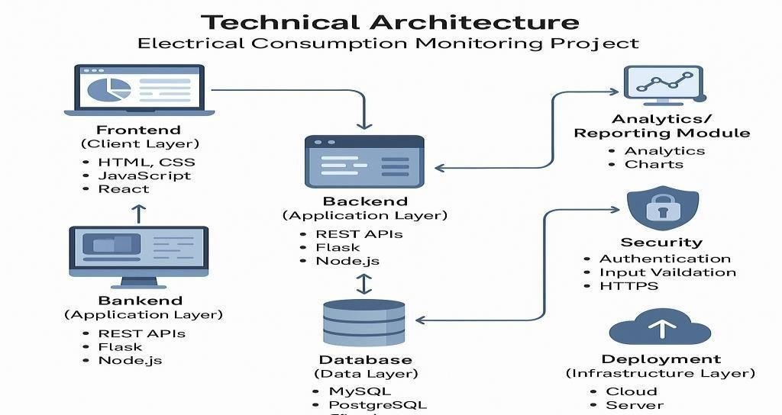
Table 1: - Components and Technologies Used

S.No | Component | Description | Technology Used
1 | Data Collection Script | Reads real-time electricity usage from meter or sensor. | Python, Arduino C++, Serial Communication
2 | Data Transmission  Module | Sends usage data to the backend or cloud. | HTTP, MQTT, Python requests, ESP32 firmware
3 | Backend Server | Handles incoming data, user requests, and processes logic. | Flask / Node.js / PHP, REST APIs

4 | Database | Stores electricity data and user info. | MySQL, MongoDB, Firebase
5 | Web Dashboard  (Frontend) | Visualizes electricity consumption in charts and tables. | HTML, CSS, JS, Bootstrap, Chart.js
6 | Authentication Module | Manages user login, registration, and access control. | Firebase Auth, JWT, PHP Sessions
7 | Notification System  (Opt.) | Alerts users when consumption exceeds threshold (SMS/email/push). | SMTP, Firebase Cloud Messaging, Twilio API

Table2:- Characteristics and Technologies Used

S.No | Characteristics | Technologies Used
1. | Real-time data reading | Python, Arduino C++

2. | Wireless data transmission | MQTT, HTTP, ESP32, Python requests
3. | Scalable and secure server-side processing | Flask, Node.js, PHP, REST APIs
4. | Interactive and responsive user interface | HTML, CSS, JavaScript, Chart.js, Bootstrap
5. | Reliable data storage and retrieval | MySQL, MongoDB, Firebase

